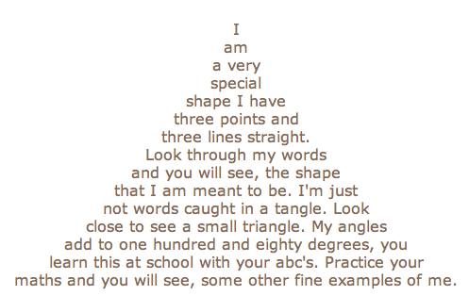

Green and speckled legs,
Hop on logs and lily pads
Splash in cool water.
PUMPKIN
by Kaitlyn Guenther
 | P | iles of candy
 | U | nder the bed
 | M | ake for a delicious snack
 | P | eople
 | K | now
 | I | t’s been Halloween because
 | N | o one is without candy

Crash at two A.M.
I opened my bedroom door
A white cat ran by
Startled by the clanging fall
Of the treat jar’s metal lid

There was an Old Man in a boat,
Who said, 'I'm afloat, I'm afloat!'
When they said, 'No! you ain't!'
He was ready to faint,
That unhappy Old Man in a boat.

square
symmetrical, conventional
shaping, measuring, balancing
boxes, rooms, clocks, halos
encircling, circumnavigating, enclosing
round, continuous
circle

My Messy Room
My room
is such a mess.
Toys all over the place.
Mom says, “Clean up!” But I like it
like this.

Thrill Ride
Up. Up.
Click, click.
Wind blows
sharp in my ears.
My heart jumps. Skips.
It’s up. It’s up higher.
It’s up, up the highest.
Hands grasp at the clouds.
Then a forever pause. Still. Waiting.
Finally. Whoosh!
Steep drop
down,
down,
down.

My lady love lives far away,
And oh my heart is sad by day,
And ah my tears fall fast by night,
What may I do in such a plight.
Why, miles grow few when love is fleet,
And love, you know, hath flying feet;
Break off thy sighs and witness this,
How poor a thing mere distance is.
My love knows not I love her so,
And would she scorn me, did she know?
How may the tale I would impart
Attract her ear and storm her heart?[Pg 289]
Calm thou the tempest in my breast,
Who loves in silence loves the best,
But bide thy time, she will awake,
No night so dark but morn will break.
But though my heart so strongly yearn,
My lady loves me not in turn,
How may I win the blest reply
That my void heart shall satisfy.
Love breedeth love, be thou but true,
And soon thy love shall love thee, too;
If Fate hath meant you heart for heart,
There's naught may keep you twain apart.

I saw the other day when I went shopping in the store
A man I hadn't ever, ever seen in there before,
A man whose leg was broken and who leaned upon a crutch-
I asked him very kindly if it hurt him very much.
"Not at all!" said the broken-legg'd man.
I ran around behind him for I thought that I would see
The broken leg all bandaged up and bent back at the knee;
But I didn't see the leg at all, there wasn't any there,
So I asked him very kindly if he had it hid somewhere.
"Not at all!" said the broken-legg'd man.
"Then where," I asked him, "is it? Did a tiger bite it off?
Or did you get your foot wet when you had a nasty cough?
Did someone jump down on your leg when it was very new?
Or did you simply cut it off because you wanted to?"
"Not at all!" said the broken-legg'd man.
"What was it then?" I asked him, and this is what he said:
"I crossed a busy crossing when the traffic light was red;
A big black car came whizzing by and knocked me off my feet."
"Of course you looked both ways," I said, "before you crossed the street."
"Not at all!" said the broken-legg'd man.
"They rushed me to the hospital right quickly, "he went on,
"And when I woke in nice white sheets I saw my leg was gone;
That's why you see me walking now on nothing but a crutch."
"I'm glad," said I, "you told me, and I thank you very much!"
"Not at all!" said the broken-legg'd man.

